|  |  |
| --- | --- |
| **EX.NO: 6** | **TRAFFIC SIGN IMAGE CLASSIFICATION USING CNN** |
| **DATE:** |

**AIM:**

To develop a CNN-based traffic sign classifier using the GTSRB dataset. The model is trained, evaluated, and saved for future use.

**ALGORITHM:**

**Step 1:** Set up the environment by importing necessary libraries (TensorFlow, OpenCV, NumPy, Pandas, etc.).

**Step 2:** Define the dataset path and initialize empty lists for storing image data and labels.

**Step 3:** Check if the dataset directory exists; raise an error if it does not.

**Step 4:** Loop through all class directories (0 to 42):

* Construct the directory path for each class.
* Skip if the directory is missing or contains no images.
* Read, resize, and append each image to the dataset along with its class label.

**Step 5:** Convert the collected image data and labels into NumPy arrays.

* If no data is found, raise an error.

**Step 6:** Split the dataset into training and testing sets (80% training, 20% testing).

**Step 7:** Convert labels into one-hot encoded format for multi-class classification.

**Step 8:** Define the CNN architecture using multiple convolutional, pooling, dropout, and dense layers.

**Step 9:** Compile the model using categorical cross-entropy loss and Adam optimizer.

**Step 10:** Train the model using the training dataset and validate it using the test dataset.

**Step 11:** Plot training history (accuracy and loss curves).

**Step 12:** Save the trained model as 'traffic_classifier.h5'.

**PROGRAM:**

import os

import cv2

import numpy as np

import pandas as pd

import tensorflow as tf

from sklearn.model_selection import train_test_split

from tensorflow.keras.utils import to_categorical

from tensorflow.keras.models import Sequential

from tensorflow.keras.layers import Conv2D, MaxPool2D, Dense, Flatten, Dropout

import matplotlib.pyplot as plt

# Number of classes in the GTSRB dataset

classes = 43

# Path to the dataset

data_dir = r"C:\dlexp\archive\Train"

# Prepare data and labels

data = []

labels = []

# Check if data_dir exists

if not os.path.exists(data_dir):

    raise FileNotFoundError(f"Dataset path does not exist: {data_dir}")

# Load images and labels

for i in range(classes):

    path = os.path.join(data_dir, str(i))

    if not os.path.exists(path):

        print(f"Skipping missing directory: {path}")

        continue

    images = os.listdir(path)

    if len(images) == 0:

        print(f"No images found in {path}")

        continue

    for img in images:

        img_path = os.path.join(path, img)

        try:

            image = cv2.imread(img_path)

            if image is None:

                print(f"Failed to load image: {img_path}")

                continue

            image = cv2.resize(image, (30, 30))

            data.append(image)

            labels.append(i)

        except Exception as e:

            print(f"Error loading image {img_path}: {e}")

# Convert to numpy arrays

data = np.array(data)

labels = np.array(labels)

if data.size == 0:

    raise ValueError("No data was loaded. Please check the dataset path and folder structure.")

print("Data shape:", data.shape)

print("Labels shape:", labels.shape)

# Train-test split

X_train, X_test, y_train, y_test = train_test_split(data, labels, test_size=0.2, random_state=42)

print("Train set size:", X_train.shape, y_train.shape)

print("Test set size:", X_test.shape, y_test.shape)

# One-hot encode labels

y_train = to_categorical(y_train, classes)

y_test = to_categorical(y_test, classes)

# Model architecture

model = Sequential([

    Conv2D(32, (5, 5), activation='relu', input_shape=(30, 30, 3)),

    Conv2D(64, (5, 5), activation='relu'),

    MaxPool2D((2, 2)),

    Dropout(0.15),

    Conv2D(128, (3, 3), activation='relu'),

    Conv2D(256, (3, 3), activation='relu'),

    MaxPool2D((2, 2)),

    Dropout(0.2),

    Flatten(),

    Dense(512, activation='relu'),

    Dropout(0.25),

    Dense(classes, activation='softmax')

])

# Compile the model

model.compile(loss='categorical_crossentropy', optimizer='adam', metrics=['accuracy'])

model.summary()

# Train the model

history = model.fit(X_train, y_train, batch_size=128, epochs=10, validation_data=(X_test, y_test))

# Plot training history

plt.figure(figsize=(20, 5))

plt.subplot(1, 2, 1)

plt.plot(history.history['accuracy'], label='Training Accuracy')

plt.plot(history.history['val_accuracy'], label='Validation Accuracy')

plt.title('Model Accuracy')

plt.xlabel('Epoch')

plt.ylabel('Accuracy')

plt.legend()

plt.grid()

plt.subplot(1, 2, 2)

plt.plot(history.history['loss'], label='Training Loss')

plt.plot(history.history['val_loss'], label='Validation Loss')

plt.title('Model Loss')

plt.xlabel('Epoch')

plt.ylabel('Loss')

plt.legend()

plt.grid()

plt.show()

# Save the trained model

model.save('traffic_classifier.h5')

print("Model saved as 'traffic_classifier.h5'")

**OUTPUT:**

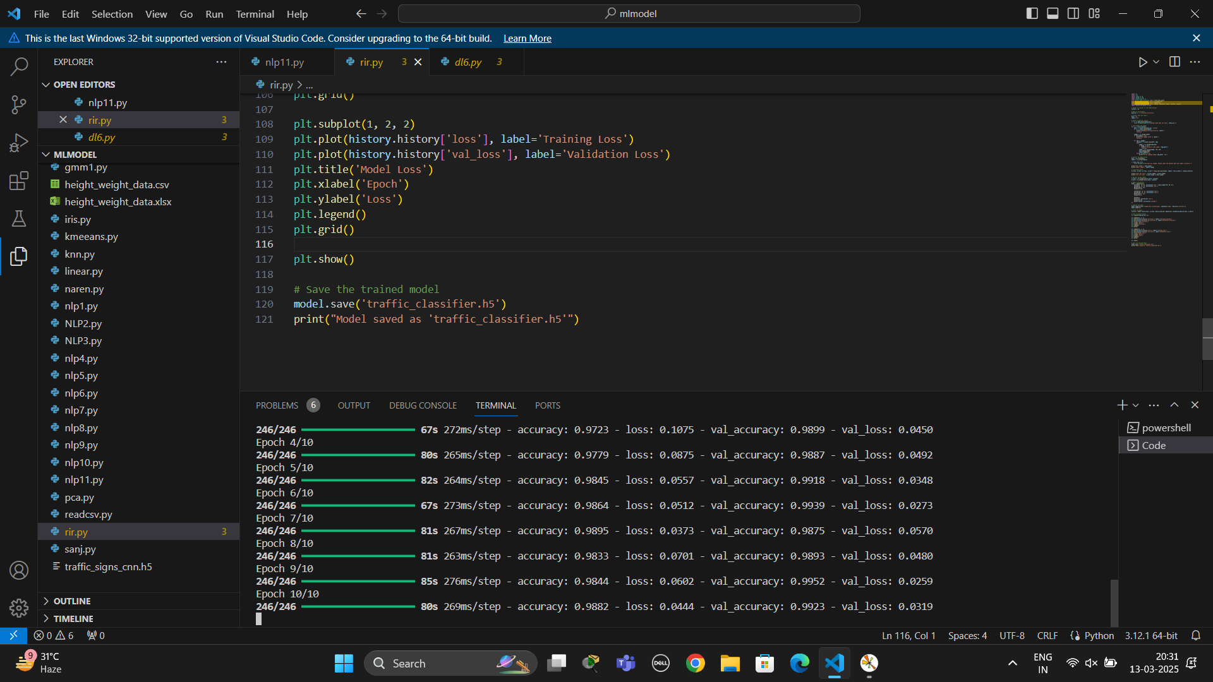

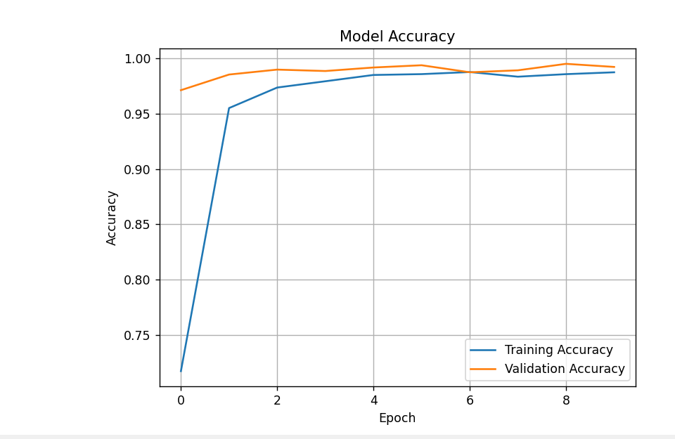

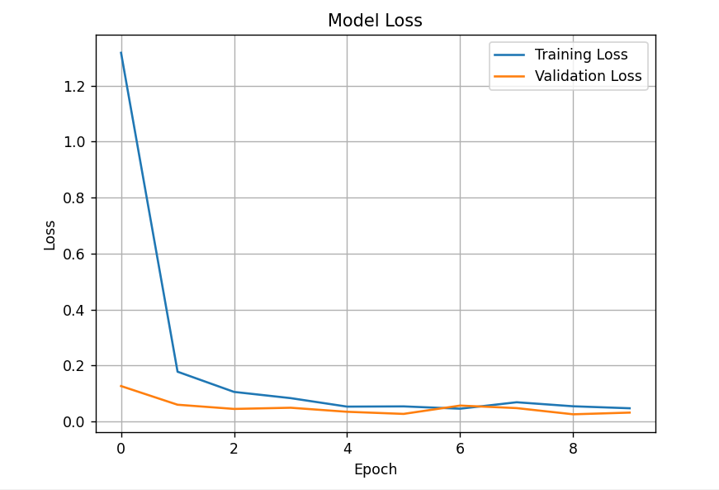

**RESULT:**

The trained CNN model successfully classifies traffic signs with high accuracy. The model is saved as 'traffic_classifier.h5' for future use.

|  |  |
| --- | --- |
| **EX.NO: 7** | **HUMAN ACTION RECOGNITION** |
| **DATE:** |

**AIM:**

To develop a deep learning model for recognizing human actions from images using EfficientNetB7. This enhances applications in surveillance, sports analysis, and human-computer interaction.

**ALGORITHM:**

**Step 1:** Load the dataset, including image file paths and corresponding labels.  
**Step 2:** Visualize class distribution and sample images from the dataset.  
**Step 3:** Preprocess images by resizing and converting them into numpy arrays.  
**Step 4:** Encode labels and apply one-hot encoding for classification.  
**Step 5:** Load the EfficientNetB7 model as a base and freeze its layers.  
**Step 6:** Add custom layers for classification and compile the model.  
**Step 7:** Train the model using the processed image dataset.  
**Step 8:** Evaluate model performance using accuracy and loss plots.  
**Step 9:** Test the model with new images and predict human actions.  
**Step 10:** Display predictions with images for visualization.

**PROGRAM:**

#Import libraries

import os

import glob

import random

import numpy as np

import pandas as pd

import tensorflow as tf

from tensorflow import keras

from keras import layers

from keras.models import Sequential

from keras.layers import Conv2D, MaxPooling2D, Activation, Dropout, Flatten, Dense

from tensorflow.keras.preprocessing.image import ImageDataGenerator

from tqdm import tqdm

from PIL import Image

from tensorflow.keras.utils import to_categorical

import seaborn as sns

import matplotlib.image as img

import matplotlib.pyplot as plt

import plotly.express as px

#Set the correct dataset path

DATASET_PATH = r"C:\Users\rr817\OneDrive\Documents\dl7\archive\Human Action Recognition"

#Load CSV data

train_data = pd.read_csv(os.path.join(DATASET_PATH, "Training_set.csv"))

test_data = pd.read_csv(os.path.join(DATASET_PATH, "Testing_set.csv"))

#Get image file paths

train_fol = glob.glob(os.path.join(DATASET_PATH, "train", "*"))

test_fol = glob.glob(os.path.join(DATASET_PATH, "test", "*"))

#Display first few rows of train data

print("Training Data Preview:")

print(train_data.head())

#Visualize class distribution using Plotly

HAR = train_data['label'].value_counts().reset_index()

HAR.columns = ['label', 'count']

fig = px.pie(HAR, values='count', names='label', title='Distribution of Human Activity')

fig.show()

#Function to display random images from train data

def display_random_images():

    num = random.randint(0, len(train_data) - 1)

    img_filename = train_data.iloc[num]['filename']

    label = train_data.iloc[num]['label']

    img_path = os.path.join(DATASET_PATH, "train", img_filename)

    if os.path.exists(img_path):

        image = img.imread(img_path)

        plt.imshow(image)

        plt.title(f"Label: {label}")

        plt.axis('off')

        plt.show()

    else:

        print(f"File not found: {img_path}")

# Display 3 random images

display_random_images()

display_random_images()

display_random_images()

#Prepare image data for training

img_data = []

img_label = []

for i, row in train_data.iterrows():

    img_path = os.path.join(DATASET_PATH, "train", row['filename'])

    if os.path.exists(img_path):

        img = Image.open(img_path)

        img_data.append(np.asarray(img.resize((160, 160))))

        img_label.append(row['label'])

# Convert to numpy arrays

img_data = np.array(img_data)

img_labels = pd.factorize(img_label)[0]

y_train = to_categorical(img_labels)

print(f"Image data shape: {img_data.shape}")

print(f"Label data shape: {y_train.shape}")

#Build the model using EfficientNetB7

img_shape = (160, 160, 3)

efficientnet_model = Sequential()

base_model = tf.keras.applications.EfficientNetB7(

    include_top=False,

    input_shape=img_shape,

    pooling="avg",

    weights="imagenet"

)

# Freeze base model layers

for layer in base_model.layers:

    layer.trainable = False

# Add custom layers

efficientnet_model.add(base_model)

efficientnet_model.add(Flatten())

efficientnet_model.add(Dense(512, activation="relu"))

efficientnet_model.add(Dense(len(HAR['label']), activation="softmax"))

# Compile the model

efficientnet_model.compile(optimizer="adam", loss="categorical_crossentropy", metrics=["accuracy"])

efficientnet_model.summary()

#Train the model

history = efficientnet_model.fit(img_data, y_train, epochs=40, batch_size=32)

#Plot loss and accuracy

plt.figure(figsize=(12, 5))

# Loss plot

plt.subplot(1, 2, 1)

plt.plot(history.history["loss"])

plt.title("Model Loss")

plt.xlabel("Epochs")

plt.ylabel("Loss")

# Accuracy plot

plt.subplot(1, 2, 2)

plt.plot(history.history["accuracy"])

plt.title("Model Accuracy")

plt.xlabel("Epochs")

plt.ylabel("Accuracy")

plt.show()

#Function to predict human action

def read_img(fn):

    img = Image.open(fn)

    return np.asarray(img.resize((160, 160)))

def test_predict(test_image):

    img_array = np.array([read_img(test_image)])

    result = efficientnet_model.predict(img_array)

    predicted_class = np.argmax(result)

    probability = np.max(result) * 100

    label = HAR.iloc[predicted_class]['label']

    print(f"Predicted class: {label} (Probability: {probability:.2f}%)")

    image = img.imread(test_image)

    plt.imshow(image)

    plt.title(f"Prediction: {label}")

    plt.axis('off')

    plt.show()

#Test prediction on random test images

test_img_1 = os.path.join(DATASET_PATH, "test", "Image_1001.jpg")

test_img_2 = os.path.join(DATASET_PATH, "test", "Image_101.jpg")

test_predict(test_img_1)

test_predict(test_img_2)

**OUTPUT:**

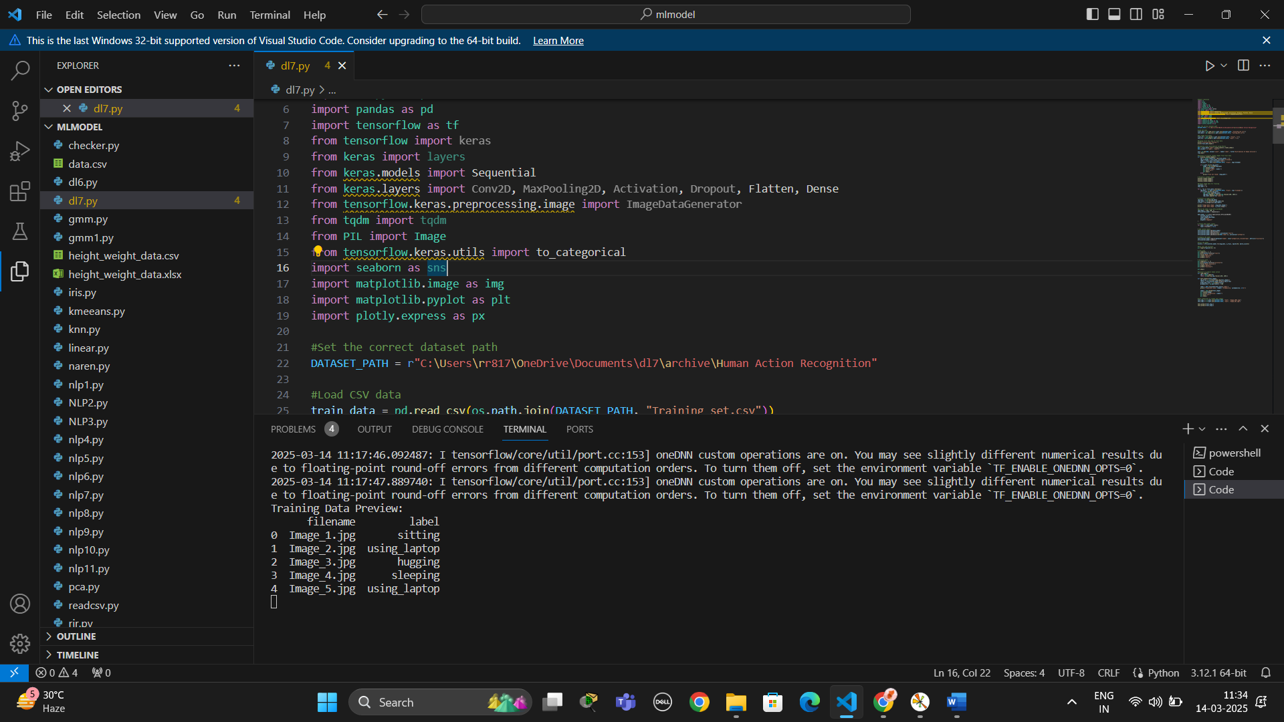

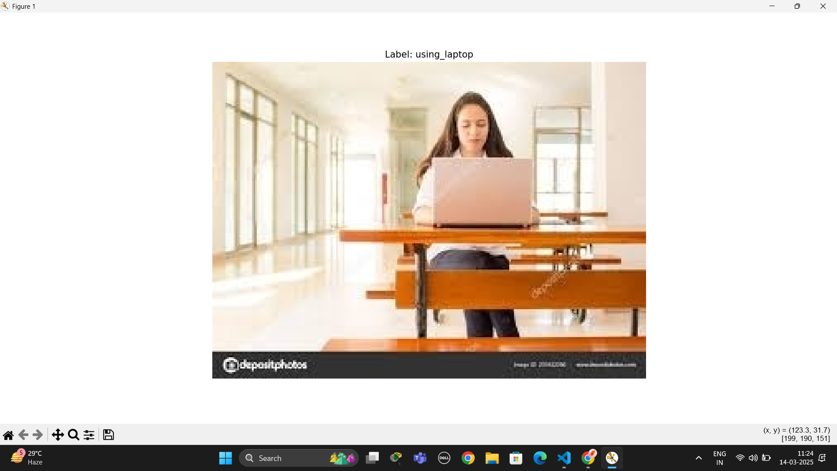

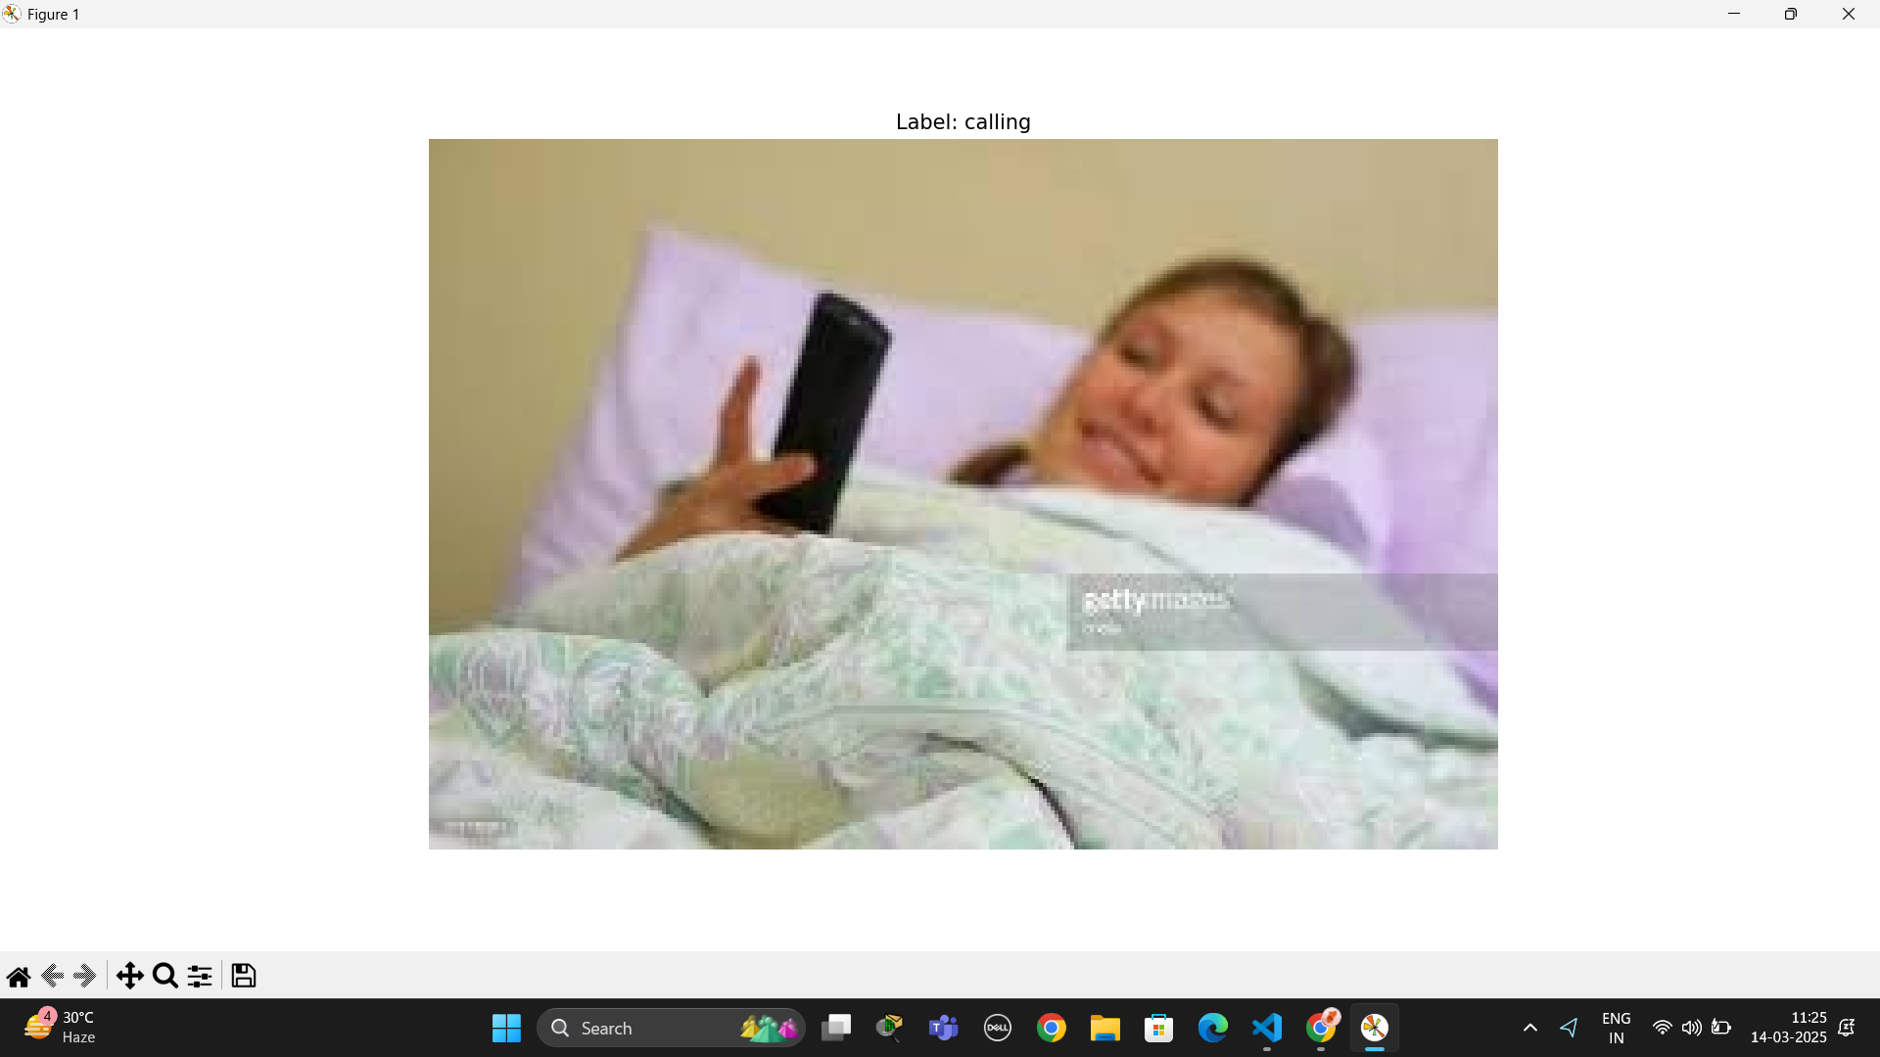

**RESULT:**

The model achieved high accuracy in classifying human actions using EfficientNetB7. Predictions were visualized with images, demonstrating reliable recognition of activities.

|  |  |
| --- | --- |
| **EX.NO: 8** | **PREDICTING CREDIT FRAUD WITH TENSORFLOW** |
| **DATE:** |

**AIM:**

To develop a fraud detection model using TensorFlow that identifies fraudulent transactions with high accuracy.

**ALGORITHM:**

**Step 1:** Load the dataset from Google Drive and perform an initial exploration of fraud and normal transactions.

**Step 2:** Visualize the distribution of transaction time and amount for both fraud and normal cases.

**Step 3:** Preprocess the data by removing irrelevant features, creating new fraud-indicative features, and normalizing values.

**Step 4:** Split the dataset into training, validation, and testing sets, ensuring a balanced ratio between fraud and normal transactions.

**Step 5:** Standardize features to have a mean of 0 and a standard deviation of 1 for efficient model training.

**Step 6:** Define a neural network with three hidden layers, using the sigmoid activation function and dropout for regularization.

**Step 7:** Compile and train the model using the Adam optimizer and categorical cross-entropy loss.

**Step 8:** Evaluate the model performance on validation and test datasets, checking accuracy and loss.

**Step 9:** Use t-SNE to visualize fraud and normal transactions in a lower-dimensional space.

**Step 10:** Analyze results and make adjustments if necessary to improve fraud detection accuracy.

**PROGRAM:**

import pandas as pd

import numpy as np

import tensorflow as tf

from sklearn.model_selection import train_test_split

import matplotlib.pyplot as plt

from sklearn.utils import shuffle

from sklearn.metrics import confusion_matrix

import seaborn as sns

import matplotlib.gridspec as gridspec

from sklearn.preprocessing import StandardScaler

from sklearn.manifold import TSNE

from google.colab import drive

drive.mount('/content/drive')

df = pd.read_csv("/content/drive/MyDrive/creditcard.csv")

df.describe()

print ("Fraud")

print (df.Time[df.Class == 1].describe())

print ()

print ("Normal")

print (df.Time[df.Class == 0].describe())

f, (ax1, ax2) = plt.subplots(2, 1, sharex=True, figsize=(12,4))

bins = 50

ax1.hist(df.Time[df.Class == 1], bins = bins)

ax1.set_title('Fraud')

ax2.hist(df.Time[df.Class == 0], bins = bins)

ax2.set_title('Normal')

plt.xlabel('Time (in Seconds)')

plt.ylabel('Number of Transactions')

plt.show()

print ("Fraud")

print (df.Amount[df.Class == 1].describe())

print ()

print ("Normal")

print (df.Amount[df.Class == 0].describe())

f, (ax1, ax2) = plt.subplots(2, 1, sharex=True, figsize=(12,4))

bins = 30

ax1.hist(df.Amount[df.Class == 1], bins = bins)

ax1.set_title('Fraud')

ax2.hist(df.Amount[df.Class == 0], bins = bins)

ax2.set_title('Normal')

plt.xlabel('Amount ($)')

plt.ylabel('Number of Transactions')

plt.yscale('log')

plt.show()

df['Amount_max_fraud'] = 1

df.loc[df.Amount <= 2125.87, 'Amount_max_fraud'] = 0

f, (ax1, ax2) = plt.subplots(2, 1, sharex=True, figsize=(12,6))

ax1.scatter(df.Time[df.Class == 1], df.Amount[df.Class == 1])

ax1.set_title('Fraud')

ax2.scatter(df.Time[df.Class == 0], df.Amount[df.Class == 0])

ax2.set_title('Normal')

plt.xlabel('Time (in Seconds)')

plt.ylabel('Amount')

plt.show()

import matplotlib.pyplot as plt

import seaborn as sns

import pandas as pd

import matplotlib.gridspec as gridspec

# Assuming the target column is 'Class' and 'v_features' is your list of features

target_column = 'Class'  # Replace with the actual target column name

v_features = ['Feature1', 'Feature2', 'Feature3']  # Update with the actual feature names

# Check the columns in the DataFrame

print("Columns in the DataFrame:", df.columns)

# Verify that the columns in v_features exist in the DataFrame

for feature in v_features:

    if feature not in df.columns:

        print(f"Warning: {feature} is not found in the DataFrame columns.")

    else:

        print(f"{feature} found in DataFrame.")

# Create the figure and gridspec layout

plt.figure(figsize=(12, 28*4))

gs = gridspec.GridSpec(28, 1)

# Loop through each feature and plot the distributions for fraudulent and normal transactions

for i, cn in enumerate(v_features):

    if cn in df.columns:

        ax = plt.subplot(gs[i])

        sns.histplot(df[cn][df[target_column] == 1], bins=50, color='blue', kde=True, label='Fraud')

        sns.histplot(df[cn][df[target_column] == 0], bins=50, color='red', kde=True, label='Normal')

        ax.set_xlabel('')

        ax.set_title('Histogram of feature: ' + str(cn))

        ax.legend()

    else:

        print(f"Feature '{cn}' not found in DataFrame.")

plt.show()

#Drop all of the features that have very similar distributions between the two types of transactions.

df = df.drop(['V28','V27','V26','V25','V24','V23','V22','V20','V15','V13','V8'], axis =1)

#Based on the plots above, these features are created to identify values where fraudulent transaction are

df['V1_'] = df.V1.map(lambda x: 1 if x < -3 else 0)

df['V2_'] = df.V2.map(lambda x: 1 if x > 2.5 else 0)

df['V3_'] = df.V3.map(lambda x: 1 if x < -4 else 0)

df['V4_'] = df.V4.map(lambda x: 1 if x > 2.5 else 0)

df['V5_'] = df.V5.map(lambda x: 1 if x < -4.5 else 0)

df['V6_'] = df.V6.map(lambda x: 1 if x < -2.5 else 0)

df['V7_'] = df.V7.map(lambda x: 1 if x < -3 else 0)

df['V9_'] = df.V9.map(lambda x: 1 if x < -2 else 0)

df['V10_'] = df.V10.map(lambda x: 1 if x < -2.5 else 0)

df['V11_'] = df.V11.map(lambda x: 1 if x > 2 else 0)

df['V12_'] = df.V12.map(lambda x: 1 if x < -2 else 0)

df['V14_'] = df.V14.map(lambda x: 1 if x < -2.5 else 0)

df['V16_'] = df.V16.map(lambda x: 1 if x < -2 else 0)

df['V17_'] = df.V17.map(lambda x: 1 if x < -2 else 0)

df['V18_'] = df.V18.map(lambda x: 1 if x < -2 else 0)

df['V19_'] = df.V19.map(lambda x: 1 if x > 1.5 else 0)

df['V21_'] = df.V21.map(lambda x: 1 if x > 0.6 else 0)

#Create a new feature for normal (non-fraudulent) transactions.

df.loc[df.Class == 0, 'Normal'] = 1

df.loc[df.Class == 1, 'Normal'] = 0

#Rename 'Class' to 'Fraud'.

df = df.rename(columns={'Class': 'Fraud'})

#492 fraudulent transactions, 284,315 normal transactions.

#0.172% of transactions were fraud.

print(df.Normal.value_counts())

print()

print(df.Fraud.value_counts())

pd.set_option("display.max_columns",101)

df.head()

#Create dataframes of only Fraud and Normal transactions.

Fraud = df[df.Fraud == 1]

Normal = df[df.Normal == 1]

# Set X_train equal to 80% of the fraudulent transactions.

X_train = Fraud.sample(frac=0.8)

count_Frauds = len(X_train)

# Add 80% of the normal transactions to X_train.

X_train = pd.concat([X_train, Normal.sample(frac = 0.8)], axis = 0)

# X_test contains all the transaction not in X_train.

X_test = df.loc[~df.index.isin(X_train.index)]

#Shuffle the dataframes so that the training is done in a random order.

X_train = shuffle(X_train)

X_test = shuffle(X_test)

#Add our target features to y_train and y_test.

y_train = X_train.Fraud

y_train = pd.concat([y_train, X_train.Normal], axis=1)

y_test = X_test.Fraud

y_test = pd.concat([y_test, X_test.Normal], axis=1)

#Drop target features from X_train and X_test.

X_train = X_train.drop(['Fraud','Normal'], axis = 1)

X_test = X_test.drop(['Fraud','Normal'], axis = 1)

#Check to ensure all of the training/testing dataframes are of the correct length

print(len(X_train))

print(len(y_train))

print(len(X_test))

print(len(y_test))

ratio = len(X_train)/count_Frauds

y_train.Fraud *= ratio

y_test.Fraud *= ratio

#Names of all of the features in X_train.

features = X_train.columns.values

#Transform each feature in features so that it has a mean of 0 and standard deviation of 1;

#this helps with training the neural network.

for feature in features:

    mean, std = df[feature].mean(), df[feature].std()

    X_train.loc[:, feature] = (X_train[feature] - mean) / std

    X_test.loc[:, feature] = (X_test[feature] - mean) / std

# Split the testing data into validation and testing sets

split = int(len(y_test)/2)

inputX = X_train.to_numpy()

inputY = y_train.to_numpy()

inputX_valid = X_test.to_numpy()[:split]

inputY_valid = y_test.to_numpy()[:split]

inputX_test = X_test.to_numpy()[split:]

inputY_test = y_test.to_numpy()[split:]

import tensorflow as tf

from tensorflow.keras import layers, models

# Number of input nodes.

input_nodes = 37

# Multiplier maintains a fixed ratio of nodes between each layer.

multiplier = 1.5

# Number of nodes in each hidden layer

hidden_nodes1 = 18

hidden_nodes2 = round(hidden_nodes1 * multiplier)

hidden_nodes3 = round(hidden_nodes2 * multiplier)

# Define the model using the Keras Functional API

inputs = layers.Input(shape=(input_nodes,))  # Input layer

# layer 1

x = layers.Dense(hidden_nodes1, activation='sigmoid')(inputs)  # Hidden layer 1

# layer 2

x = layers.Dense(hidden_nodes2, activation='sigmoid')(x)  # Hidden layer 2

# layer 3

x = layers.Dense(hidden_nodes3, activation='sigmoid')(x)  # Hidden layer 3

x = layers.Dropout(0.9)(x)  # Dropout layer

# layer 4

outputs = layers.Dense(2, activation='softmax')(x)  # Output layer

# Build the model

model = models.Model(inputs=inputs, outputs=outputs)

# Compile the model

model.compile(optimizer=tf.optimizers.Adam(learning_rate=0.005),

              loss='categorical_crossentropy',

              metrics=['accuracy'])

# Parameters for training

training_epochs = 5

batch_size = 2048

n_samples = y_train.shape[0]

# Train the model

history = model.fit(inputX, inputY, epochs=training_epochs, batch_size=batch_size,

validation_data=(inputX_valid, inputY_valid))

# Print the results after training

print("Optimization Finished!")

import pandas as pd

import numpy as np

import matplotlib.pyplot as plt

from sklearn.preprocessing import StandardScaler

from sklearn.manifold import TSNE

# Read the data

tsne_data = pd.read_csv("/content/drive/MyDrive/creditcard.csv")

# Set df2 equal to all of the fraudulent and 10,000 normal transactions

df2 = tsne_data[tsne_data.Class == 1]

df2 = pd.concat([df2, tsne_data[tsne_data.Class == 0].sample(n = 10000)], axis = 0)

# Scale features to improve the training ability of TSNE

standard_scaler = StandardScaler()

df2_std = standard_scaler.fit_transform(df2.drop('Class', axis=1))  # Drop the target column

# Set y equal to the target values (Class column)

y = df2.iloc[:,-1].values  # Use .iloc to select the last column

# Perform t-SNE

tsne = TSNE(n_components=2, random_state=0)

x_test_2d = tsne.fit_transform(df2_std)

# Build the scatter plot with the two types of transactions

color_map = {0: 'red', 1: 'blue'}

plt.figure()

for idx, cl in enumerate(np.unique(y)):

    plt.scatter(x=x_test_2d[y == cl, 0],

                y=x_test_2d[y == cl, 1],

                c=color_map[idx],

                label=cl)

plt.xlabel('X in t-SNE')

plt.ylabel('Y in t-SNE')

plt.legend(loc='upper left')

plt.title('t-SNE visualization of test data')

plt.show()

#Set df_used to the fraudulent transactions' dataset.

df_used = Fraud

#Add 10,000 normal transactions to df_used.

df_used = pd.concat([df_used, Normal.sample(n = 10000)], axis = 0)

#Scale features to improve the training ability of TSNE.

df_used_std = standard_scaler.fit_transform(df_used)

#Set y_used equal to the target values.

y_used = df_used.iloc[:,-1].values

x_test_2d_used = tsne.fit_transform(df_used_std)

color_map = {1:'red', 0:'blue'}

plt.figure()

for idx, cl in enumerate(np.unique(y_used)):

    plt.scatter(x=x_test_2d_used[y_used==cl,0],

                y=x_test_2d_used[y_used==cl,1],

                c=color_map[idx],

                label=cl)

plt.xlabel('X in t-SNE')

plt.ylabel('Y in t-SNE')

plt.legend(loc='upper left')

plt.title('t-SNE visualization of test data')

plt.show()

**OUTPUT:**

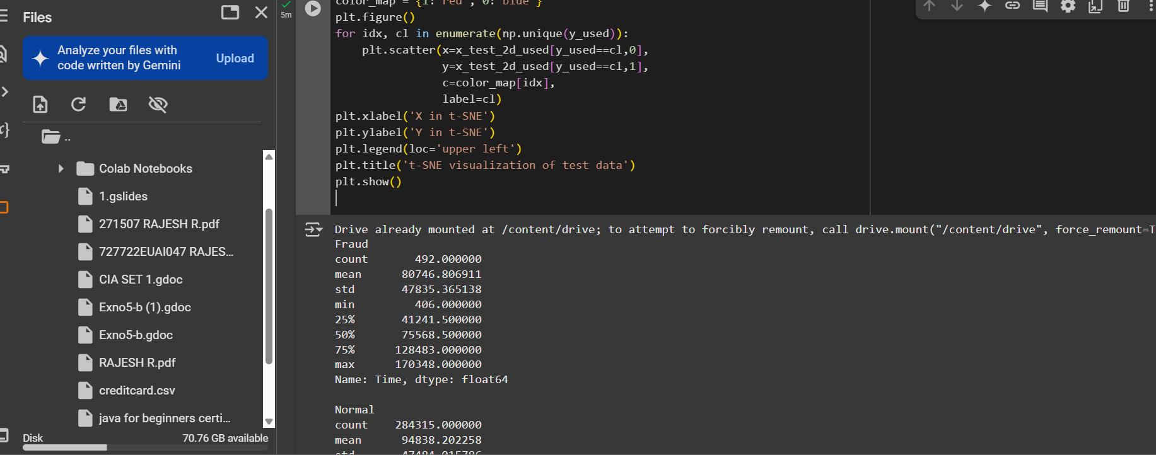

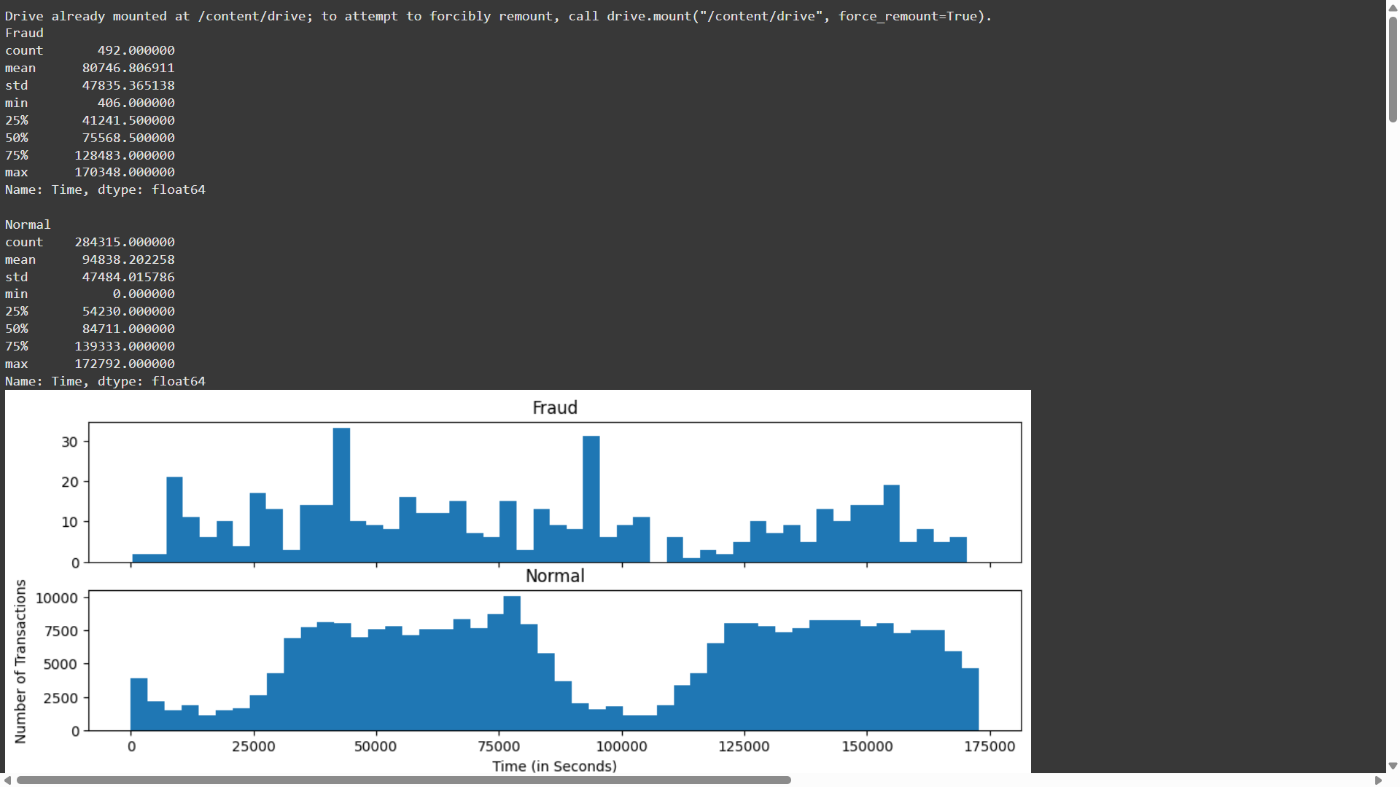

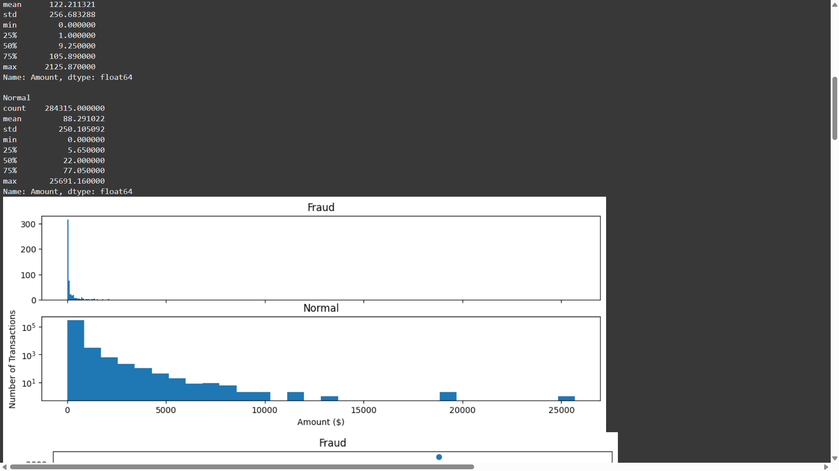

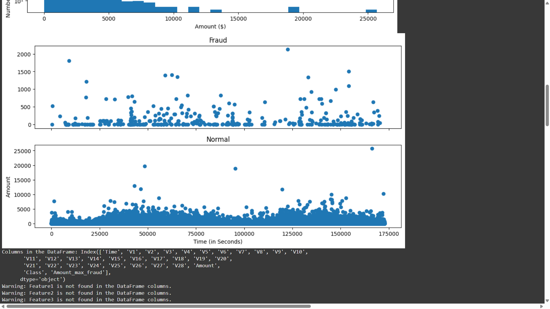

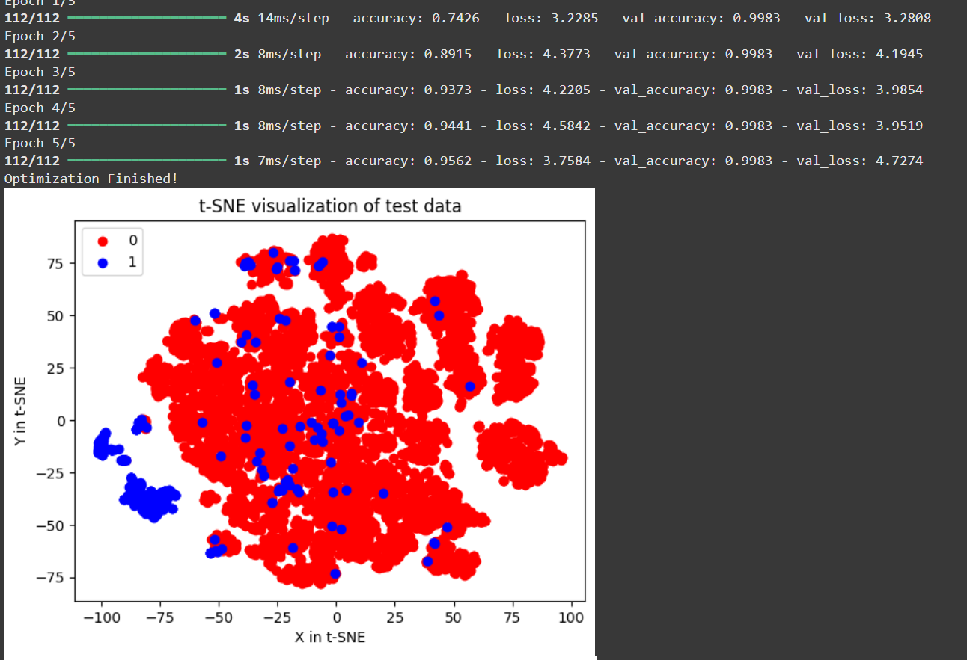

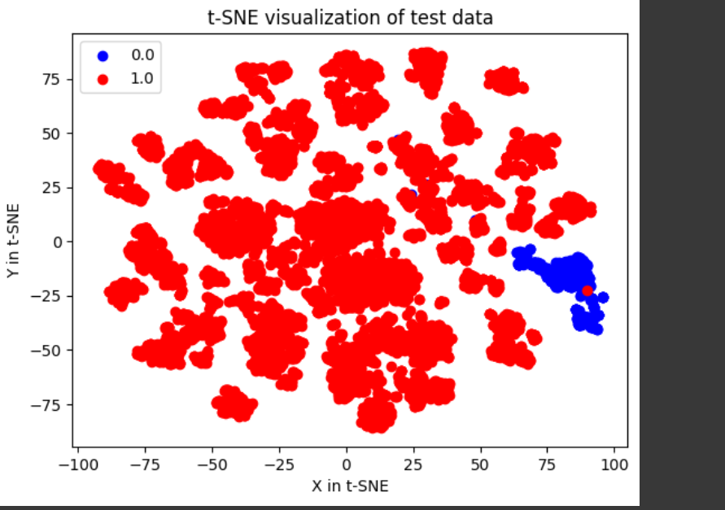

**RESULT:**

The trained model achieved high accuracy in detecting fraudulent transactions while minimizing false positives. The t-SNE visualization confirmed clear separation between fraud and normal transactions.

|  |  |
| --- | --- |
| **EX.NO: 9** | **IMAGE AUGMENTATION IN DEEP LEARNING** |
| **DATE:** |

**AIM:**

To enhance the diversity of training data by applying transformations such as flipping, rotation, cropping, and brightness adjustments, improving model generalization and robustness.

**ALGORITHM:**

**Step 1:** Load the input image from the dataset.  
**Step 2:** Choose augmentation techniques (e.g., flipping, rotation, brightness adjustment).  
**Step 3:** Apply random flipping (horizontal/vertical) to the image.  
**Step 4:** Apply random rotation within a specified degree range.  
**Step 5:** Adjust brightness and contrast for variation.  
**Step 6:** Resize the image to a fixed size if needed.  
**Step 7:** Add random noise to simulate real-world variations.  
**Step 8:** Apply transformations using an augmentation library (e.g., Albumentations, Imgaug).  
**Step 9:** Store or visualize the augmented images.  
**Step 10:** Use augmented images to train a machine learning model.

**PROGRAM:**

import random

from skimage import color

import pylab as pl

import os

import glob

import numpy as np

import scipy as sp

import pandas as pd

# skimage

from skimage.io import imshow, imread, imsave

from skimage.transform import rotate, AffineTransform, warp, rescale, resize, downscale_local_mean

from skimage import color, data

from skimage.exposure import adjust_gamma

from skimage.util import random_noise

# OpenCV-Python

import cv2

# imgaug

import imageio

import imgaug as ia

import imgaug.augmenters as iaa

# Albumentations

import albumentations as A

# Augmentor

import Augmentor

# Keras

from tensorflow.keras.preprocessing.image import ImageDataGenerator, array_to_img, img_to_array, load_img

# SOLT

import solt

import solt.transforms as slt

# Visualization

import matplotlib.pyplot as plt

import matplotlib.image as mpimg

import seaborn as sns

import os

os.environ["TF_ENABLE_ONEDNN_OPTS"] = "1"

import tensorflow as tf  # Import TensorFlow after setting the environment variable

print(1)

# Set additional display options for report

pd.set_option("display.max_columns", 100)

th_props = [('font-size', '13px'), ('background-color', 'white'),

            ('color', '#666666')]

td_props = [('font-size', '15px'), ('background-color', 'white')]

styles = [dict(selector="td", props=td_props), dict(selector="th",

            props=th_props)]

print(2)

# Warnings

import warnings

warnings.filterwarnings("ignore")

# Helper function to display the images in a grid

def gallery(array, ncols=3):

    '''

    Function to arrange images into a grid.

    INPUT:

        array - numpy array containing images

        ncols - number of columns in resulting image grid

    OUTPUT:

        result - reshaped array into a grid with given number of columns

    '''

    nindex, height, width, intensity = array.shape

    nrows = nindex // ncols

    assert nindex == nrows * ncols

    result = (array.reshape(nrows, ncols, height, width, intensity)

              .swapaxes(1, 2)

              .reshape(height * nrows, width * ncols, intensity))

    return result

print(3)

# Data Path (updated to D:/lab)

Image_Data_Path = r"C:\\Users\\rr817\\OneDrive\Desktop\DL9\\plant-pathology-2020-fgvc7\\images\\"

train_data = pd.read_csv(r"C:\\Users\\rr817\\OneDrive\\Desktop\DL9\\plant-pathology-2020-fgvc7\\train.csv")

test_data = pd.read_csv(r"C:\\Users\\rr817\\OneDrive\\Desktop\\DL9\\plant-pathology-2020-fgvc7\\test.csv")

# Loading the training images

def load_image(image_id):

    file_path = image_id + ".jpg"

    image = imread(Image_Data_Path + file_path)

    return image

train_images = train_data["image_id"][:50].apply(load_image)

print(4)

print(4)

# Plotting multiple images using subplots

fig, ax = plt.subplots(nrows=2, ncols=3, figsize=(30, 16))

for col in range(3):

    for row in range(2):

        ax[row, col].imshow(train_images.loc[train_images.index[row * 3 + col]])

        ax[row, col].set_xticks([])

        ax[row, col].set_yticks([])

image = train_images[15]

imshow(image)

print(image.shape)

print(5)

# Red filter [R,G,B]

red_filter = [1, 0, 0]

# Blue filter

blue_filter = [0, 0, 1]

# Green filter

green_filter = [0, 1, 0]

# Matplotlib code to display

fig, ax = plt.subplots(nrows=1, ncols=3, figsize=(30, 16))

ax[0].imshow(image * red_filter)

ax[0].set_title("Red Filter", fontweight="bold", size=30)

ax[1].imshow(image * blue_filter)

ax[1].set_title("Blue Filter", fontweight="bold", size=30)

ax[2].imshow(image * green_filter)

ax[2].set_title("Green Filter", fontweight="bold", size=30)

print(6)

# Import color sub-module

# Converting image to grayscale

grayscale_image = color.rgb2gray(image)

grayscale_image.shape

imshow(grayscale_image)

# Horizontally flipped

hflipped_image = np.fliplr(image)  # fliplr reverse the order of columns of pixels in matrix

# Vertically flipped

vflipped_image = np.flipud(image)  # flipud reverse the order of rows of pixels in matrix

fig, ax = plt.subplots(nrows=1, ncols=3, figsize=(30, 16))

ax[0].imshow(image)

ax[0].set_title("Original Image", size=30)

ax[1].imshow(hflipped_image)

ax[1].set_title("Horizontally flipped", size=30)

ax[2].imshow(vflipped_image)

ax[2].set_title("Vertically flipped", size=30)

# Clockwise rotation

rot_clockwise_image = rotate(image, angle=45)

# Anticlockwise rotation

rot_anticlockwise_image = rotate(image, angle=-45)

fig, ax = plt.subplots(nrows=1, ncols=3, figsize=(30, 16))

ax[0].imshow(image)

ax[0].set_title("Original Image", size=30)

ax[1].imshow(rot_clockwise_image)

ax[1].set_title("+45 degree Rotation", size=30)

ax[2].imshow(rot_anticlockwise_image)

ax[2].set_title("-45 degree rotation", size=30)

print(6)

# Random Crop

def randRange(a, b):

    '''

    a utility function to generate random float values in desired range

    '''

    return pl.rand() * (b - a) + a

def randomCrop(im):

    '''

    Cropping the image in the center from a random margin from the borders

    '''

    margin = 1 / 3.5

    start = [int(randRange(0, im.shape[0] * margin)),

             int(randRange(0, im.shape[1] * margin))]

    end = [int(randRange(im.shape[0] * (1-margin), im.shape[0])),

           int(randRange(im.shape[1] * (1-margin), im.shape[1]))]

    cropped_image = im[start[0]:end[0], start[1]:end[1]]

    return cropped_image

fig, ax = plt.subplots(nrows=1, ncols=2, figsize=(20, 12))

ax[0].imshow(image)

ax[0].set_title("Original Image", size=20)

ax[1].imshow(randomCrop(image))

ax[1].set_title("Cropped", size=20)

# Brightness adjustment

image_bright = adjust_gamma(image, gamma=0.5, gain=1)

image_dark = adjust_gamma(image, gamma=2, gain=1)

fig, ax = plt.subplots(nrows=1, ncols=3, figsize=(20, 12))

ax[0].imshow(image)

ax[0].set_title("Original Image", size=20)

ax[1].imshow(image_bright)

ax[1].set_title("Brightened Image", size=20)

ax[2].imshow(image_dark)

ax[2].set_title("Darkened Image", size=20)

print(7)

# Resizing the image

image_resized = resize(image, (image.shape[0] // 2, image.shape[1] // 2), anti_aliasing=True)

fig, ax = plt.subplots(nrows=1, ncols=2, figsize=(30, 16))

ax[0].imshow(image)

ax[0].set_title("Original Image", size=20)

ax[1].imshow(image_resized)

ax[1].set_title("Resized image", size=20)

# Adding noise to the image

noisy_image = random_noise(image)

fig, ax = plt.subplots(nrows=1, ncols=2, figsize=(30, 16))

ax[0].imshow(image)

ax[0].set_title("Original Image", size=20)

ax[1].imshow(noisy_image)

ax[1].set_title("Image after adding noise", size=20)

# Example with OpenCV for flips and rotations

image13 = train_images[13]

imshow(image13)

print(image13.shape)

plt.axis('off')

# Vertical flip

img_flip_ud = cv2.flip(image13, 0)

plt.imshow(img_flip_ud)

# Horizontal flip

img_flip_lr = cv2.flip(image13, 1)

plt.imshow(img_flip_lr)

fig, ax = plt.subplots(nrows=1, ncols=2, figsize=(20, 12))

ax[0].imshow(img_flip_ud)

ax[0].set_title("Vertical flip", size=20)

ax[1].imshow(img_flip_lr)

ax[1].set_title("Horizontal flip", size=20)

# Rotation using OpenCV

img_rotate_90_clockwise = cv2.rotate(image13, cv2.ROTATE_90_CLOCKWISE)

img_rotate_90_counterclockwise = cv2.rotate(image13, cv2.ROTATE_90_COUNTERCLOCKWISE)

img_rotate_180 = cv2.rotate(image13, cv2.ROTATE_180)

fig, ax = plt.subplots(nrows=1, ncols=3, figsize=(20, 12))

ax[0].imshow(img_rotate_90_clockwise)

ax[0].set_title("90 degrees clockwise", size=20)

ax[1].imshow(img_rotate_90_counterclockwise)

ax[1].set_title("90 degrees anticlockwise", size=20)

ax[2].imshow(img_rotate_180)

ax[2].set_title("180 degree rotation", size=20)

# Resize image using OpenCV

def resize_image(image, w, h):

    resized_image = cv2.resize(image, (w, h))

    return resized_image

imshow(resize_image(image13, 500, 500))

# Add light to image using OpenCV

def add_light(image, gamma):

    invGamma = 1.0 / gamma

    table = np.array([((i / 255.0) ** invGamma) * 255

                      for i in np.arange(0, 256)]).astype("uint8")

    image = cv2.LUT(image, table)

    return image

imshow(add_light(image13, 2))

# Crop image using OpenCV

def crop_image(image, y1, y2, x1, x2):

    image = image[y1:y2, x1:x2]

    return image

imshow(crop_image(image13, 200, 800, 250, 1500))  # (y1, y2, x1, x2)

# Apply Gaussian Blur to the image

def gaussian_blur(image, blur):

    image = cv2.GaussianBlur(image, (5, 5), blur)

    return image

imshow(gaussian_blur(image13, 0))

plt.show()

**OUTPUT:**

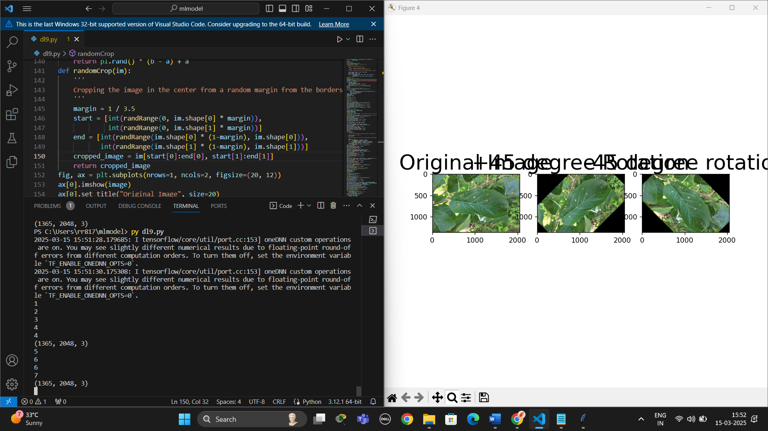

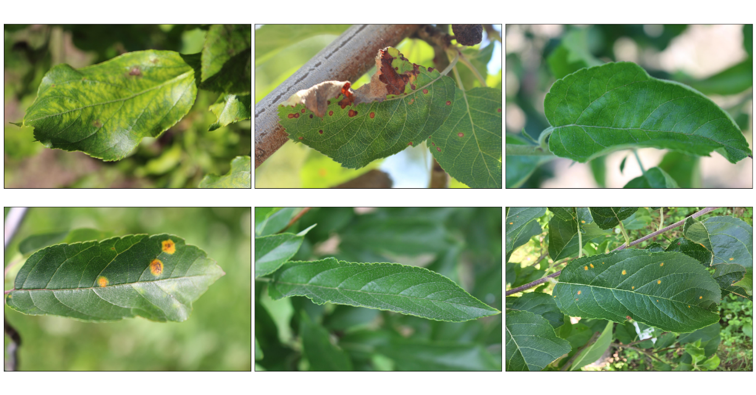

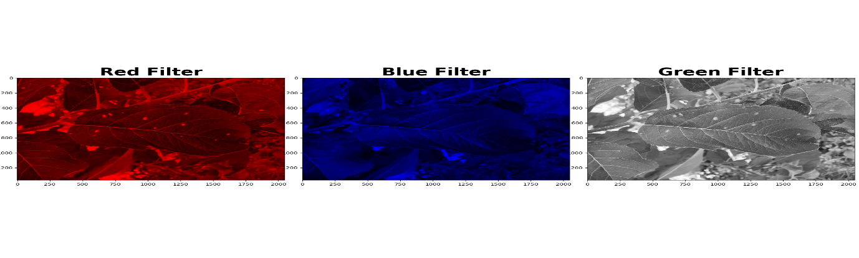

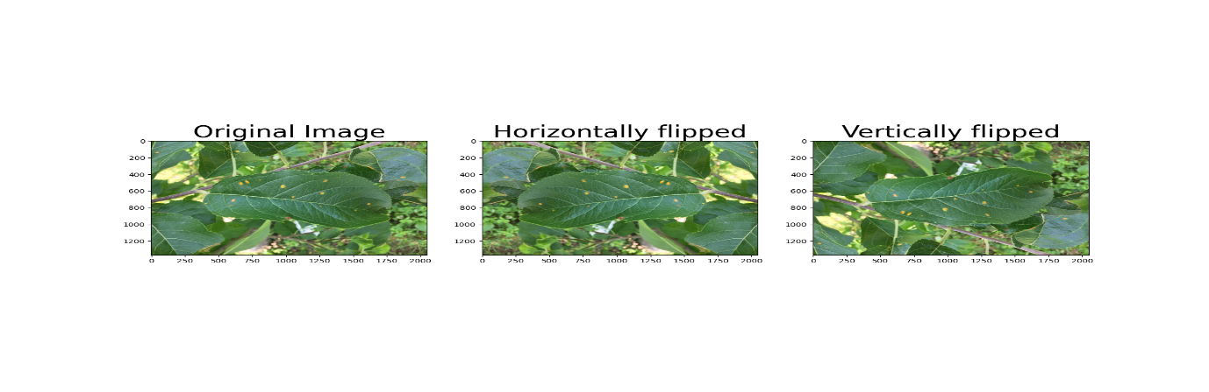

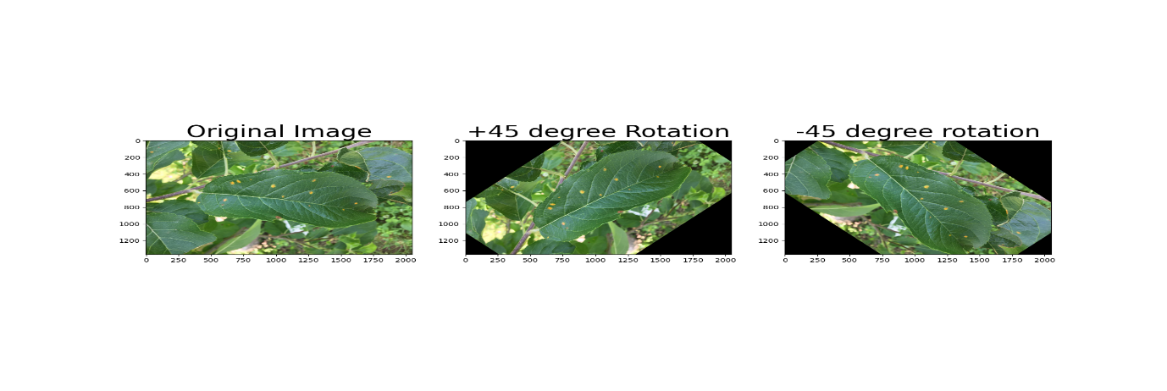

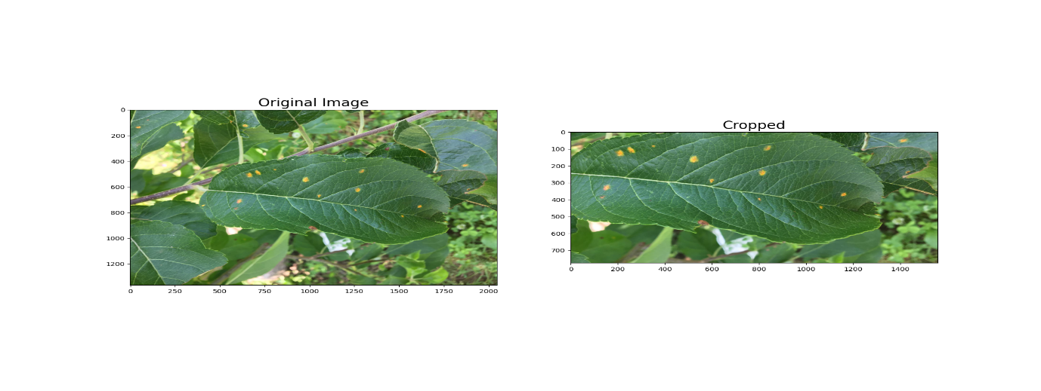

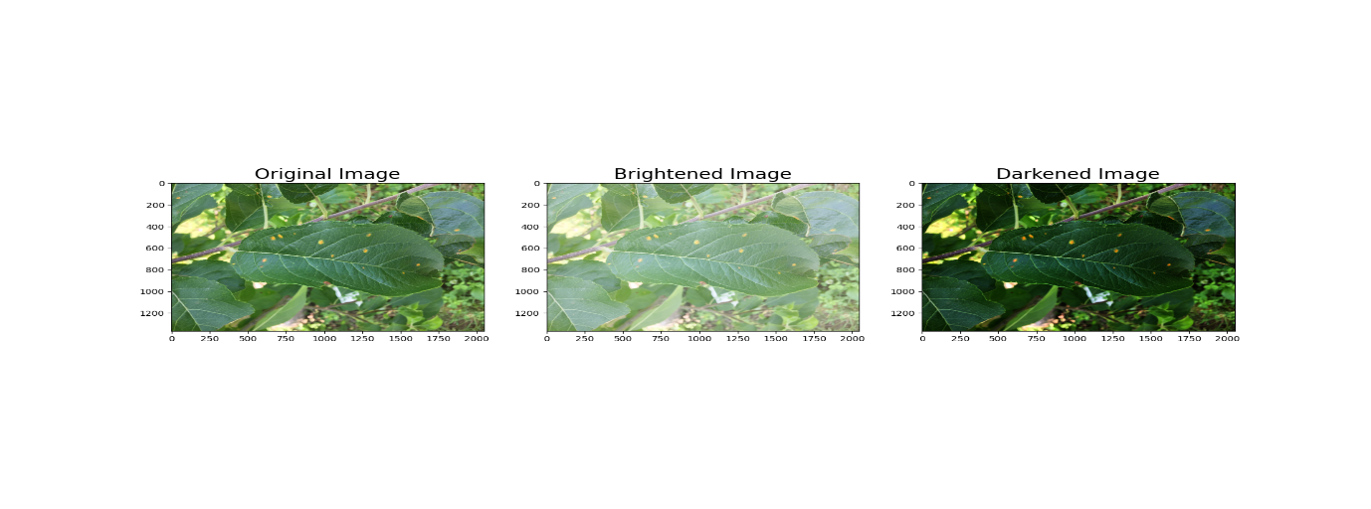

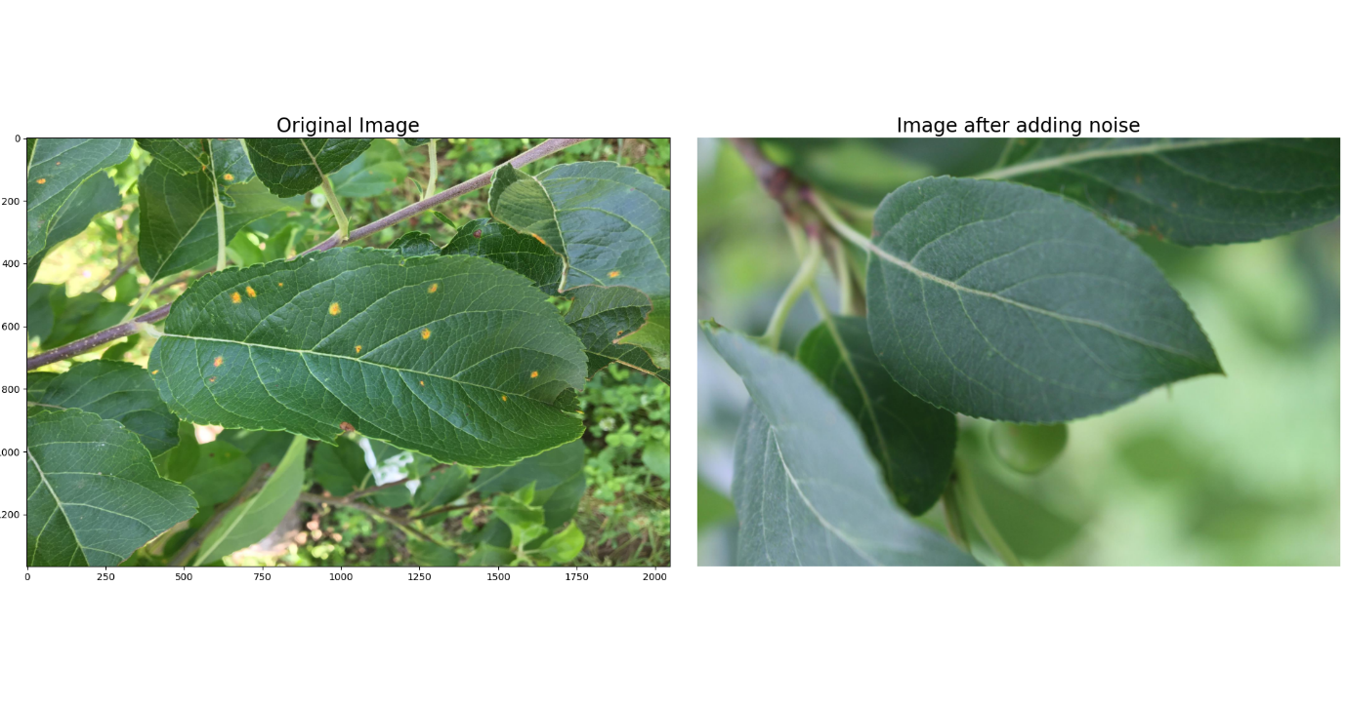

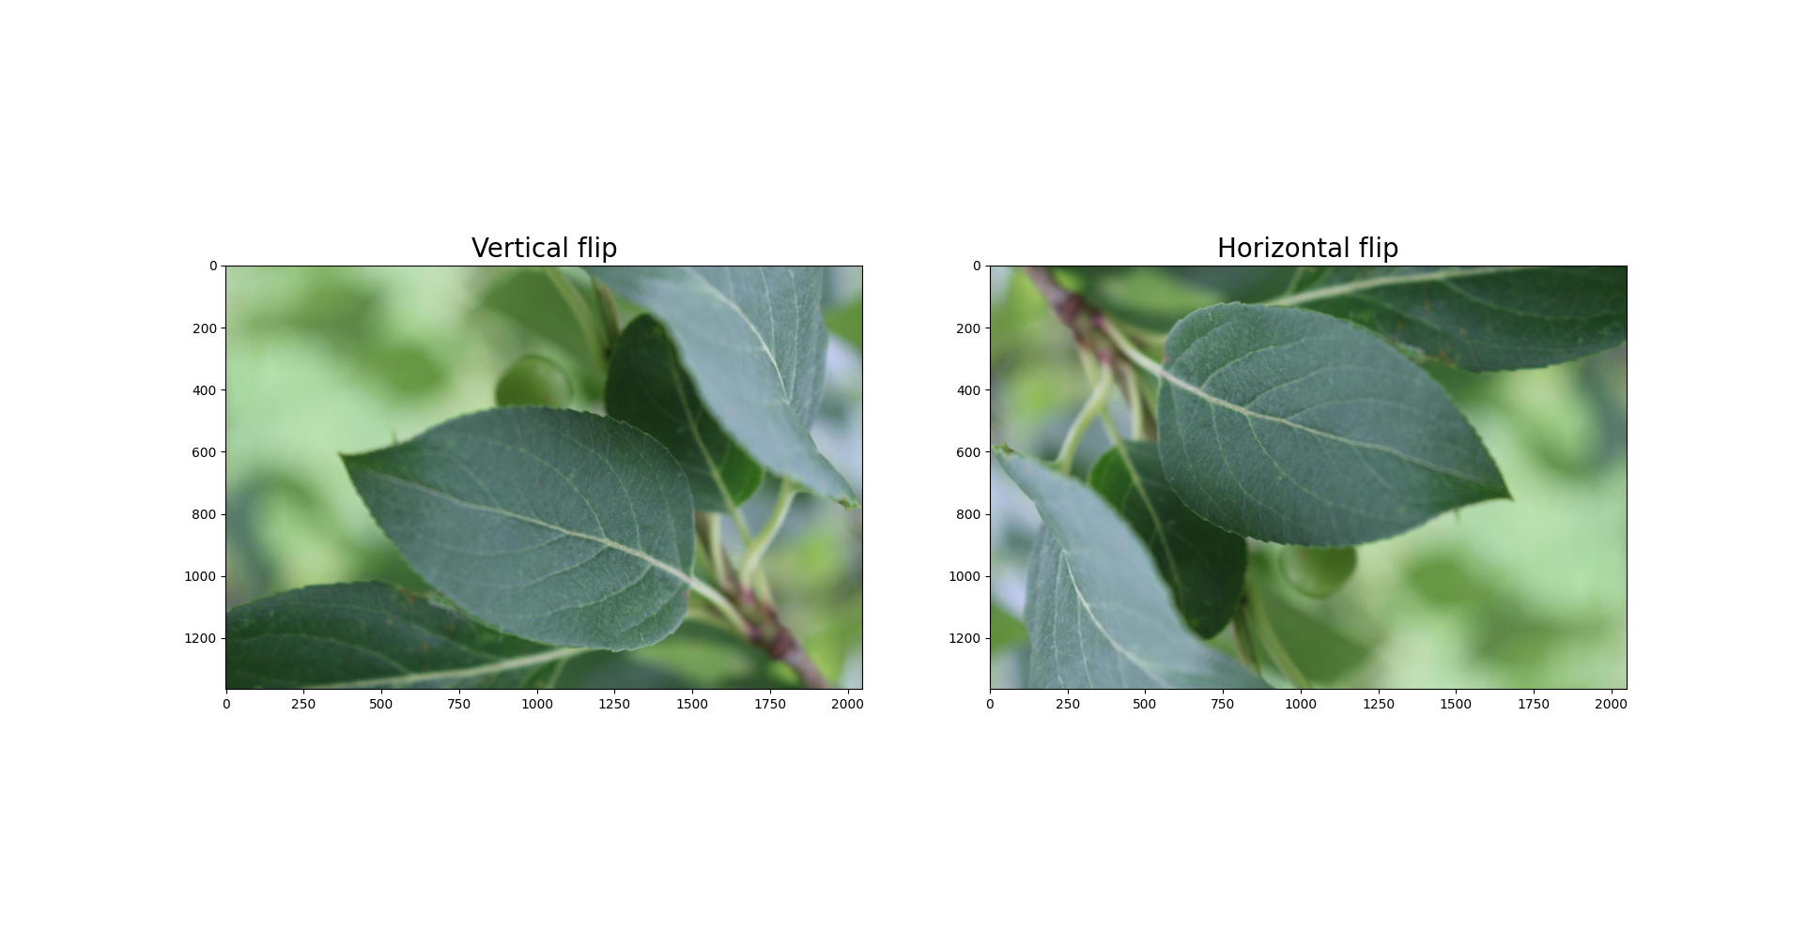

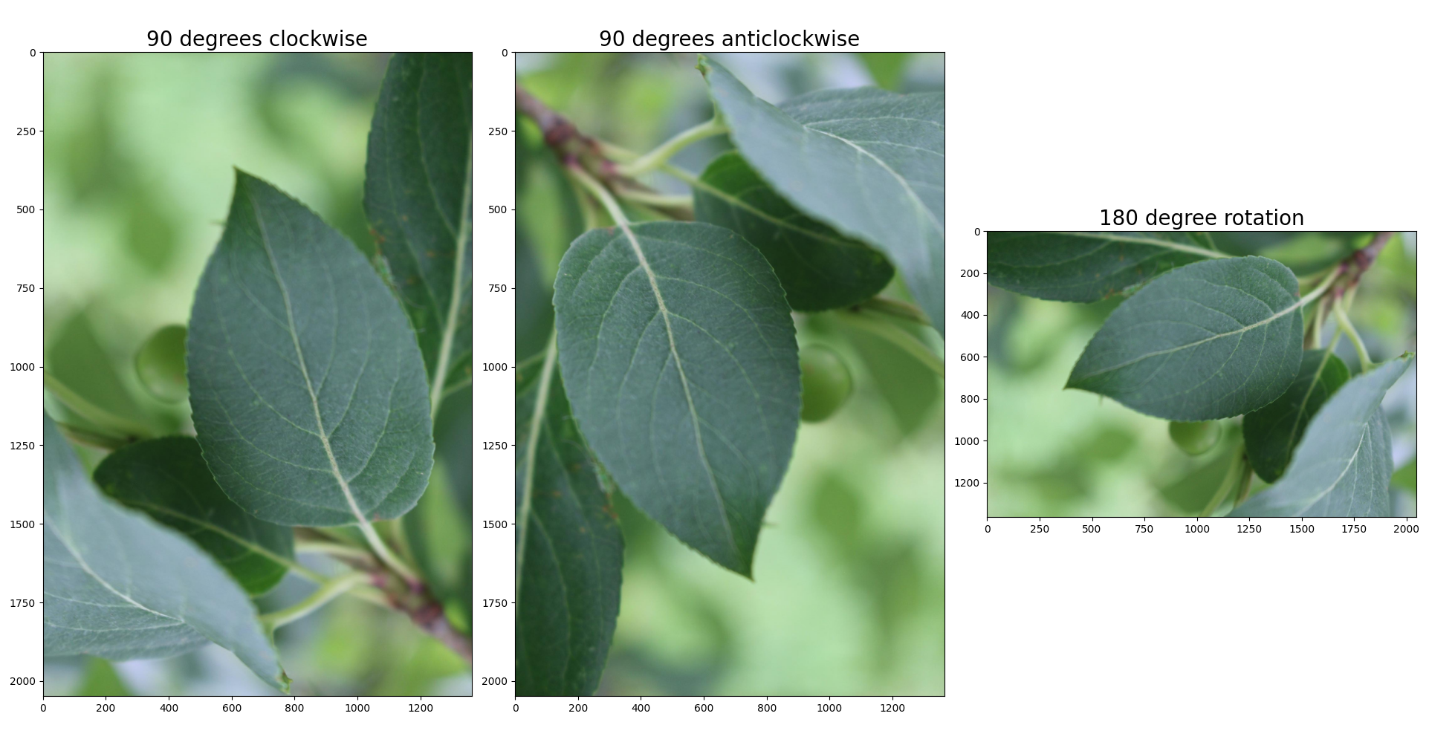

**RESULT:**

The augmented images exhibit variations in orientation, brightness, and noise, enhancing dataset diversity. This improves model generalization and robustness in real-world scenarios.

|  |  |
| --- | --- |
| **EX.NO: 10** | **TWITTER SENTIMENT ANALYSIS** |
| **DATE:** |

**AIM:**

To analyze Twitter data and classify sentiments (positive, negative, neutral, or others) using deep learning techniques.

**ALGORITHM:**

**Step 1:** Import necessary libraries such as pandas, numpy, sklearn, and spacy.

**Step 2:** Load the dataset (twitter_training.csv) into a Pandas DataFrame and display basic details.

**Step 3:** Preprocess text data by removing stop words and applying lemmatization using spaCy.

**Step 4:** Encode sentiment labels using LabelEncoder to convert categorical labels into numerical values.

**Step 5:** Split the dataset into training (80%) and testing (20%) sets using train_test_split().

**Step 6:** Create a classification pipeline with TfidfVectorizer for feature extraction and MultinomialNB for sentiment classification.

**Step 7:** Train the model using the processed training data (X_train, y_train).

**Step 8:** Predict sentiment labels for test data (X_test) and evaluate using accuracy and classification report.

**Step 9:** Replace MultinomialNB with RandomForestClassifier, retrain the model, and evaluate performance.

**Step 10:** Test the final model on new text data from twitter_validation.csv and display predicted vs. actual sentiment labels.

**PROGRAM:**

import numpy as np

import pandas as pd

from sklearn.model_selection import train_test_split

from sklearn.feature_extraction.text import TfidfVectorizer

from sklearn.preprocessing import LabelEncoder

from sklearn.pipeline import Pipeline

from sklearn.naive_bayes import MultinomialNB

from sklearn.ensemble import RandomForestClassifier

from sklearn.metrics import accuracy_score, classification_report

import spacy

# Read the dataset with name "Emotion_classify_Data.csv" and store it in a variable df

columns = ['id','country','Label','Text']

df = pd.read_csv("/content/drive/MyDrive/twitter_training.csv", names=columns)

# Print the shape of dataframe

print(df.shape)

# Print top 5 rows

df.head(5)

# Show sample

for i in range(5):

    print(f"{i+1}: {df['Text'][i]} -> {df['Label'][i]}")

df.dropna(inplace=True)

# load english language model and create nlp object from it

nlp = spacy.load("en_core_web_sm")

# use this utility function to get the preprocessed text data

def preprocess(text):

    # remove stop words and lemmatize the text

    doc = nlp(text)

    filtered_tokens = []

    for token in doc:

        if token.is_stop or token.is_punct:

            continue

        filtered_tokens.append(token.lemma_)

    return " ".join(filtered_tokens)

df['Preprocessed Text'] = df['Text'].apply(preprocess)

le_model = LabelEncoder()

df['Label'] = le_model.fit_transform(df['Label'])

X_train, X_test, y_train, y_test = train_test_split(df['Preprocessed Text'], df['Label'],

                                                    test_size=0.2, random_state=42, stratify=df['Label'])

print("Shape of X_train: ", X_train.shape)

print("Shape of X_test: ", X_test.shape)

# Create classifier

clf = Pipeline([

    ('vectorizer_tri_grams', TfidfVectorizer()),

    ('naive_bayes', (MultinomialNB()))

])

# Model training

clf.fit(X_train, y_train)

# Get prediction

y_pred = clf.predict(X_test)

# Print score

print(accuracy_score(y_test, y_pred))

# Print classification report

print(classification_report(y_test, y_pred))

clf = Pipeline([

    ('vectorizer_tri_grams', TfidfVectorizer()),

    ('naive_bayes', (RandomForestClassifier()))

])

clf.fit(X_train, y_train)

# Get the predictions for X_test and store it in y_pred

y_pred = clf.predict(X_test)

# Print Accuracy

print(accuracy_score(y_test, y_pred))

# Print the classfication report

print(classification_report(y_test, y_pred))

test_df = pd.read_csv('/content/drive/MyDrive/twitter_validation.csv', names=columns)

test_df.head()

test_text = test_df['Text'][10]

print(f"{test_text} ===> {test_df['Label'][10]}")

test_text_processed = [preprocess(test_text)]

test_text_processed

test_text = clf.predict(test_text_processed)

classes = ['Irrelevant', 'Natural', 'Negative', 'Positive']

print(f"True Label: {test_df['Label'][10]}")

print(f'Predict Label: {classes[test_text[0]]}')

**OUTPUT:**

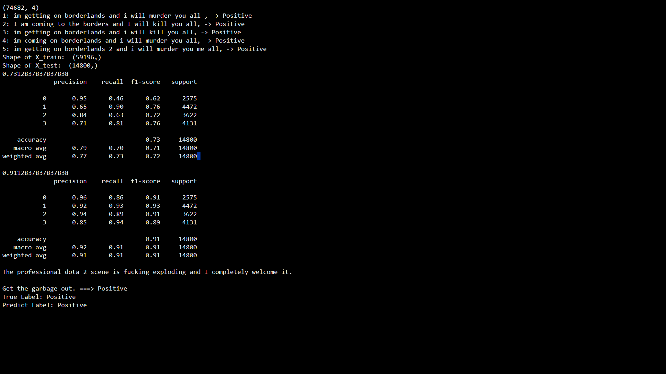

**RESULT:**

The model achieved a good accuracy in classifying sentiments, with MultinomialNB performing well on textual data. The RandomForestClassifier provided competitive results, but performance varied based on feature extraction.